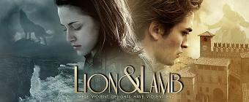
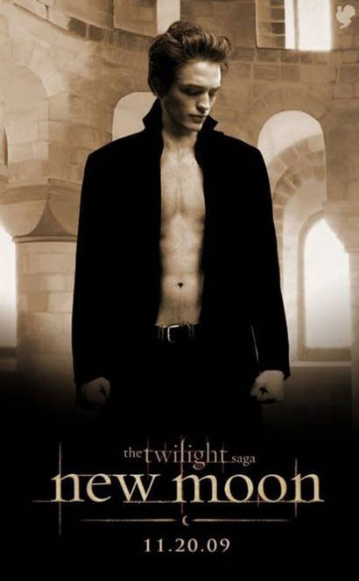
Pre-intermediate
Reading- New Moon
I am Bella Swan and I live in the rainy and grey Forks, Washington with my father, Charlie. When I moved here I was a bit sad and lonely. But then I met my boyfriend, Edward Cullen. He pretended to be about 17. After a few months there were three things I was absolutely positive: First, Edward was a vampire. Second, there was a part of him–and I didn’t know how dominant that part might be–that thirsted for my blood. And third, I was unconditionally and irrevocably in love with him. I am not frightened because he and his family drink only the blood of animals; they never sleep or eat human food and they are immortal. I am 18 now, and this was my hardest year. When I cut my finger at my birthday party, Edward’s brother, Jasper, tried to attack me. I escaped but after this Edward decided to end our relationship. He wanted to protect me, but he broke my heart. For almost a year I didn’t hear about him. A young boy, Jacob Black, became my best friend. I learnt that he is a werewolf, a mortal enemy of vampires. I often did crazy things, because when I was in danger I heard Edward’s voice in my head clearly and I did my best to hear his voice as often as I could. Once I even jumped from a cliff and I almost died. Fortunately Jacob saved me. At the same time, Alice Cullen, Edward's lovable vampire sister who has clear visions of the future, had a vision of me jumping off the cliff. Presuming I am dead, Alice immediately came to Forks to check on my father, while Edward called. Jacob answered and informed him that Charlie is at a funeral and Edward thought that he was at my funeral. Edward was extremely sad and flew to Italy to kill himself.
With Alice I rushed to Italy and saved Edward. The Volturi told us that I either die or change into a vampire. After our lucky return to Forks, Edward explained me that he only left in order to protect me, and I forgave him. The Cullens voted and I can become a vampire one day. Now, I am in confinement, but I’m the happiest girl on earth, as we are together and he promised that he will never leave me.

A) Find the words that have the same meaning:
1. solely - ____________
2. some – ____________
3. completely - __________
4. prevailing – __________
5. definitely – ____________
6. scared – ____________
7. have – ___________
8. finish – ___________
9. nearly – ___________
10. find out – ___________
11. insane – ___________
12. rock – ___________
13. foresight – ___________
14. commit suicide-
____________________
15. save - ___________

B) Find the past simple words in the text, underline and write them here. Then match the simple present form.
Past | Present | Past | Present

C) Find some adjectives and adverbs in the text, write them in the correct column and then complete the table.
ADJECTIVE  (What kind of?) | ADVERB  (How?)
sad (line2) | you write: sadly

dd

D) Are these statements True(T), False (F) or Not Stated (NS)?

Edward is 17 years old. |  | Jacob saved Bella from the ocean.
Jasper hurt Bella at the party. |  | Alice didn’t know that Bella is alive.
Bella is desperately in love with Edward. |  | When Bella did crazy things, Edward called her.
Edward’s family is human-friendly. |  | Jacob said Edward that Bella is dead.
Vampires can live forever. |  | Edward left Bella to protect her.
Bella fell in love with Jacob. |  | Bella has to stay in her room now.

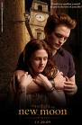

E) Answer these questions and support your answers from the text:

- Did Bella like Folks when she moved there?____________________________________________
- Was Bella sure that Edward is a vampire? _____________________________________________
- When did Jasper try to attack Bella?____________________________________________________
- Why did Edward brake up with Bella?_________________________________________________
- Was Jacob a special boy?_____________________________________
- Can Alice see the future?_____________________________________
- Why did she go back to Folks?________________________________
- Why did Edward think that Bella was dead?____________________
______________________________________________________________
- Why did Edward go to Italy?_________________________________
- Is Bella a vampire?__________________________________________



F) Match the expressions with the definition

1 - Werewolf 2- Vampire 3- Kobold 4- Shape shifter

Originating from German folklore, it is a mischievous sprite that is usually invisible. However, it can materialize in the form of an animal, fire, an object or as a human being the size of a small child. They are known to play tricks, but to also bring good luck to a household provided the owners of the home take good care of them.
They are also known as transformation, is a change in the form or shape of a person, especially a change from human form to animal form or a change in appearance from one person to another.
We all know of these blood-sucking creatures. They are undead beings that survive by feeding on the blood of the living. They look just like normal humans (for that's what they are) but have a cold white skin and can only come out in the dark.
A human, usually with Indian heritage, who can shape shift into form of an animal or change into this animal during a full moon. In mythology, it is believed a person becomes this due to being bitten by another creature. The shift from human to this form occurs during a full moon and the person looses all sense of human morals and preys on killing other humans in turn. Hair or fur sprouts from the body, the fingers and nails grow into claws

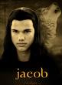

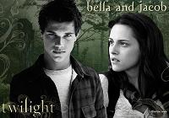

A) This is Jacob’s letter to his friend. Choose the word from the next box and write the correct forms to the places:
Dear Jensen,
I’m sorry I haven’t written before but I ____ a busy year. Thank you for your letter and the book, too.
A few years ago I ______ you about my childhood friend, Bella. She _______ back to town last year. She is a clever, shy but very funny girl. I think that I ______ in love with her. We _____ the whole summer together. Just imagine! She _____ two old motorbikes and I ______ them. Once we ____ on a tour and she had an accident. She _____ her arm but she didn’t mind. She is so brave. Sometimes she ____ crazy things, and I just _____ not understand why. We ______ in the woods and _______ very good friends. She ______ my friends and she ______ that we are werewolves. She ____ the boys jumping from the cliffs and she ______ it herself, too. She almost ______ but I _____ her.
Then suddenly her ex-boyfriend’s sister _____ and Bella _____ away. I don’t understand her. She _____ with Edward and they are together again. I’m not happy, because that boy is a vampire and I can’t stand them. It’s hard. I have to go now but I’ll call you soon.
Bye for now, Jacob

Have2x Hurt
Go Repaire
Tell Try
Can Do
Walk Become
Move Meet
Save Rush
Fall Come
Return Die
Learn Buy
Spend See
Come

B) You are Edward, write a letter and tell about Bella’s last year (the text and Jacob’s letter will help you).

C) Write questions to these answers. Use the words from the brackets. (Based on the text and the letter)
1.…………………………………………………? (WHO) | 5……………………………………………..? (WHY)
He fell in love with Bella. | Because she had a vision of Bella jumping.
2. ……………………………………………......?(WHY) | 6……………………………………………? (WHAT)
Because they rode the motorbikes. | Bella’s heart.
3. …………………………………………………?(WHO) | 7………………………………………………? (WHERE)
Jacob repaired them. | To Italy.
4………………………………………………..? (WHO) | 8……………………………………………….? (HOW)
Jacob and his friends. | Unconditionally and irrevocably.

PRE-READING TASKS

As pre-reading tasks, you can ask a few questions about reading habits and supernatural creatures:
QUESTIONS:
- What was the last book you read?
- When was the last time you bought a book?
- Do you know any films that are book adaptations? List some.
- Which is better? Reading or watching a story?
- What are the advantages/disadvantages of reading?
- Who are the vampires?
- Have you read any books about them? Can you tell a story or a tale in connection with vampires?
- What other supernatural creatures do you know?
- What can they do?
- Have you read or seen Twilight? What is it about?

KEY
A) Find the words that have opposite meaning:
1. solely - lonely
2. some – a few
3. completely - absolutely
4. prevailing – dominant
5. definitely – unconditionally
6. scared – frightened
7. have – eat
8. finish – end
9. nearly – almost
10. find out – learn
11. insane – crazy
12. rock – cliff
13. foresight – vision
14. commit suicide- kill himself
15. save - protect
A) This is Jacob’s letter to his friend. Choose the word from the next box and write the correct forms to the places:

Dear Jensen,
I’m sorry I haven’t written before but I had a busy year. Thank you for your letter and the book, too.
A few years ago I told you about my childhood friend, Bella. She moved back to town last year. She is a clever, shy but very funny girl. I think that I fell in love with her. We spent the whole summer together. Just imagine! She bought two old motorbikes and I repaired them. Once we went on a tour and she had an accident. She hurt her arm but she didn’t mind. She is so brave. Sometimes she did crazy things, and I just could not understand why. We walked in the woods and became very good friends. She met my friends and she learnt that we are werewolves. She saw the boys jumping from the cliffs and she tried it herself, too. She almost died but I saved her.
Then suddenly her ex-boyfriend’s sister came and Bella rushed away. I don’t understand her. She returned with Edward and they are together again. I’m not happy, because that boy is a vampire and you know how we can’t stand them. It’s hard. I have to go now but I’ll call you soon.
Bye for now,
Jacob

